SIMATS ENGINEERING
ASSESSMENT TOOL 2

COURSE NAME: DESIGN AND ANALYSIS OF ALGORITHMS
COURSE CODE: CSA0601

COURSE OUTCOME COVERED

CO 4: Solve optimization problems using dynamic programming and greedy strategies.
(BL4, BL5)

Assessment Tool Weightage: 20%

QUESTIONS: 7 Total Marks: 35

Annexure A

Industry Problem Solving Task

Code of Conduct:

I U.Prabhavathi/192472067 (Name / Reg No) certify that this submission is my original work and that I have adhered to the guidelines specified for this assessment.
I understand that any violation of academic integrity rules will result in disciplinary action.

Signature of the student:U.Prabhavathi

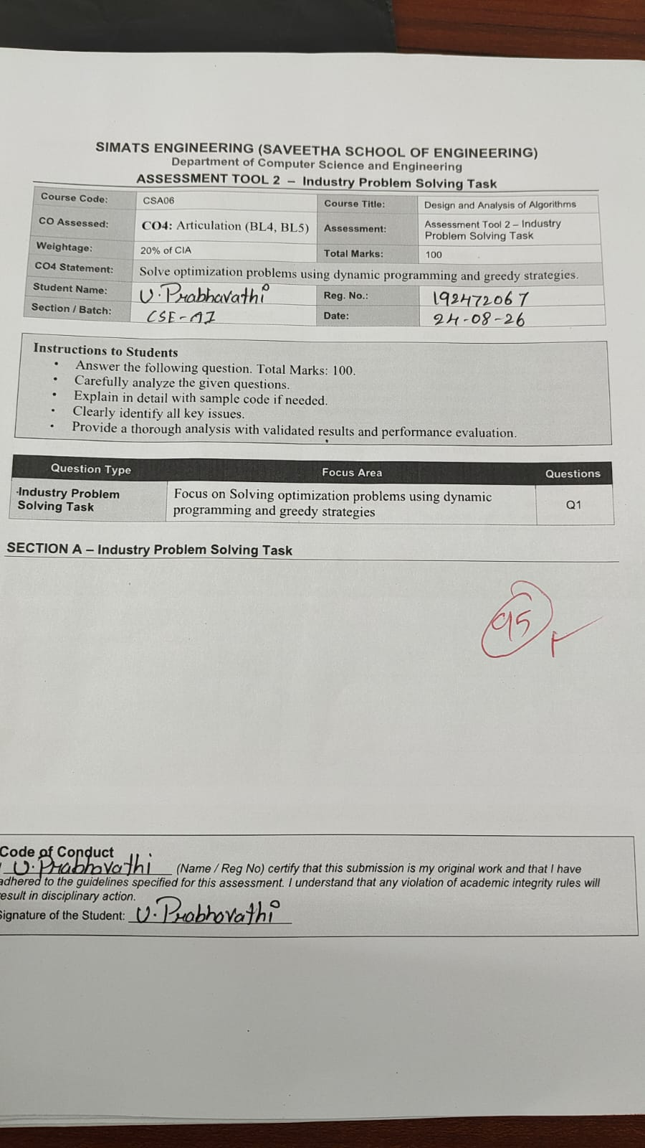
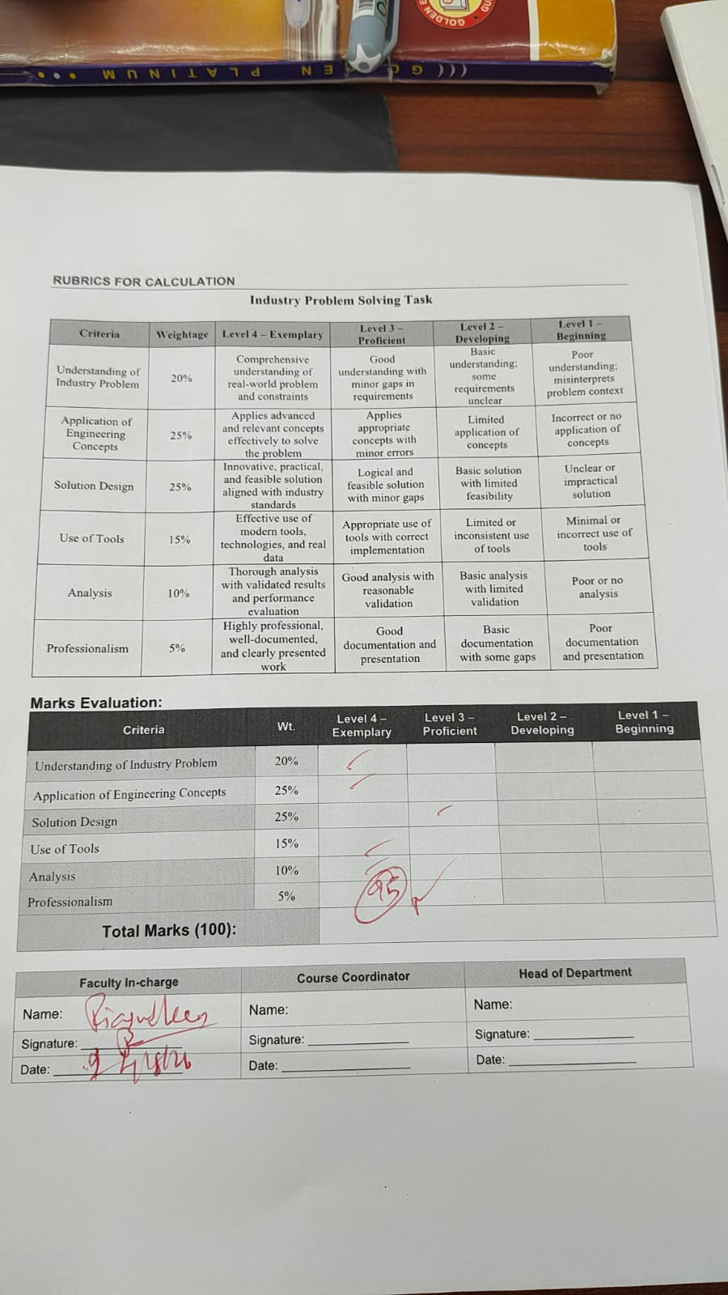

Annexure A

Industry Problem Solving Task

Q96. Smart Parking Demand Forecasting Optimization (Data Analysis + DP)
A city must forecast parking demand to optimize space allocation. Analyze how dynamic programming and data analysis can model demand. Identify constraints such as peak hours and location variability. Design a predictive allocation system. Discuss scalability. Evaluate efficiency. Interpret results in urban planning.
Q97. Autonomous Drone Path Optimization (Graph + Shortest Path)
A drone delivery system must compute optimal flight paths while avoiding obstacles. Analyze how graph algorithms can optimize routes. Identify constraints such as battery life and weather conditions. Design a scalable path planning solution. Discuss real-time adaptability. Evaluate computational complexity. Interpret results in delivery efficiency.
Q98. Smart Retail Price Recommendation Optimization (Data Analysis + DP)
A retail platform must recommend optimal prices for products. Analyze how dynamic programming can optimize pricing decisions. Identify constraints such as competition and demand. Design a scalable pricing model. Discuss implementation challenges. Evaluate efficiency. Interpret results in revenue growth.
Q99. Intelligent Network Congestion Control Optimization (Graph + Load Balancing)
A communication network must control congestion to maintain performance. Analyze how graph and load balancing algorithms can optimize traffic flow. Identify constraints such as bandwidth and latency. Design a scalable congestion control system. Discuss real-time implementation. Evaluate performance metrics. Interpret results in network efficiency.
Q100. Smart Disaster Recovery System Optimization (Scheduling + Resource Allocation)
A disaster recovery system must restore services efficiently after system failures. Analyze how scheduling and resource allocation algorithms can optimize recovery. Identify constraints such as limited resources and time-critical operations. Design a scalable recovery strategy. Discuss implementation challenges. Evaluate computational efficiency. Interpret results in system resilience.

Industry Problem Solving Task – Q96 to Q100

Q96. Smart Parking Demand Forecasting Optimization

Aim
To develop a smart parking system that forecasts parking demand and optimizes parking-space allocation using Data Analysis and Dynamic Programming.

Problem
Cities face parking shortages during peak hours while some parking areas remain unused.

Algorithm / Solution
- Collect historical parking data.
- Analyze demand based on time, location, weekday, and occupancy.
- Forecast future parking demand.
- Divide available parking spaces among different locations.
- Use Dynamic Programming to find the best allocation.
- Update the allocation using real-time parking data.

Constraints
- Limited parking spaces.
- Peak-hour demand.
- Location-based demand variation.
- Weekday/weekend differences.
- Real-time changes.

Scalability
The system can support many parking locations using cloud storage and distributed processing.

Efficiency
Dynamic Programming reduces repeated calculations and improves parking-space utilization.

Result / Interpretation
The system reduces parking shortages, improves space utilization, and helps city planners identify areas where additional parking facilities are required.

Q97. Autonomous Drone Path Optimization

Aim
To find the safest and shortest flight path for an autonomous delivery drone using Graph Algorithms and Shortest Path Algorithms.

Problem
Drones need to deliver packages while avoiding obstacles and minimizing battery consumption.

Algorithm / Solution
- Represent locations as graph nodes.
- Represent possible flight routes as edges.
- Assign weights based on distance or energy consumption.
- Remove routes containing obstacles or no-fly zones.
- Apply Dijkstra's Algorithm or A*.
- Select the shortest and safest route.
- Recalculate the path when weather or obstacles change.

Constraints
- Limited battery.
- Obstacles.
- Weather conditions.
- No-fly zones.
- Maximum flight distance.

Scalability
A* and efficient graph structures can handle large maps and multiple delivery locations.

Efficiency
Dijkstra's algorithm with a priority queue has approximately O((V+E) log V) complexity.

Result / Interpretation
The system reduces flight distance, battery usage, delivery time, and operational cost.

Q98. Smart Retail Price Recommendation Optimization

Aim
To develop a smart pricing system that recommends the best product price using Data Analysis and Dynamic Programming.

Problem
Retail companies must set prices while considering customer demand, competitors, inventory, and profit.

Algorithm / Solution
- Collect historical sales and pricing data.
- Analyze customer demand.
- Study competitor prices.
- Estimate demand for different prices.
- Define minimum and maximum price constraints.
- Use Dynamic Programming to evaluate pricing decisions.
- Select the price that provides maximum expected revenue.
- Continuously update prices using new data.

Constraints
- Customer demand.
- Competitor prices.
- Inventory.
- Seasonal changes.
- Price limits.
- Customer price sensitivity.

Scalability
The system can process thousands of products using cloud computing and parallel processing.

Efficiency
DP avoids repeated calculations and provides faster pricing decisions.

Result / Interpretation
The system can increase revenue, improve profit, maintain competitive prices, and reduce excess inventory.

Q99. Intelligent Network Congestion Control Optimization

Aim
To develop a network congestion control system using Graph Algorithms and Load Balancing to distribute network traffic efficiently.

Problem
Heavy network traffic can cause congestion, high latency, packet loss, and reduced performance.

Algorithm / Solution
- Represent network devices as graph nodes.
- Represent communication links as edges.
- Monitor traffic, bandwidth, and latency.
- Identify congested links.
- Find alternative routes using graph algorithms.
- Distribute traffic across multiple paths.
- Continuously monitor the network.
- Redirect traffic when congestion occurs.

Constraints
- Limited bandwidth.
- Network latency.
- Packet loss.
- Unequal traffic.
- Network failures.
- Changing traffic conditions.

Scalability
Distributed load balancing and hierarchical network structures can support large networks.

Performance Metrics
- Throughput.
- Latency.
- Packet loss.
- Bandwidth utilization.
- Response time.

Result / Interpretation
The system reduces congestion, improves network speed, increases bandwidth utilization, and provides reliable communication.

Q100. Smart Disaster Recovery System Optimization

Aim
To design a smart disaster recovery system using Scheduling and Resource Allocation to restore critical services quickly after system failures.

Problem
After a disaster or server failure, limited resources must be allocated to restore the most important services first.

Algorithm / Solution
- Detect the system failure.
- Identify affected services.
- Assign priority to each service.
- Identify available servers, storage, and network resources.
- Schedule critical services first.
- Allocate resources according to priority.
- Restore services.
- Monitor recovery progress.
- Reallocate resources when required.

Constraints
- Limited computing resources.
- Limited backup resources.
- Time-critical recovery.
- Service dependencies.
- Hardware failures.
- Network failures.

Scalability
Cloud resources can be added when required, and multiple services can be recovered in parallel.

Efficiency
Priority-based scheduling ensures that critical services are restored first, reducing overall downtime.

Result / Interpretation
The system minimizes recovery time, reduces service downtime, protects important services, and improves overall system resilience.

RUBRICS FOR CALCULATION
Industry Problem Solving Task

Criteria | Weightage | Level 4 – Exemplary | Level 3 – Proficient | Level 2 – Developing | Level 1 – Beginning
Understanding of Industry Problem | 20% | Comprehensive understanding of real-world problem and constraints | Good understanding with minor gaps in requirements | Basic understanding; some requirements unclear | Poor understanding; misinterprets problem context
Application of Engineering Concepts | 25% | Applies advanced and relevant concepts effectively to solve the problem | Applies appropriate concepts with minor errors | Limited application of concepts | Incorrect or no application of concepts
Solution Design | 25% | Innovative, practical, and feasible solution aligned with industry standards | Logical and feasible solution with minor gaps | Basic solution with limited feasibility | Unclear or impractical solution
Use of Tools | 15% | Effective use of modern tools, technologies, and real data | Appropriate use of tools with correct implementation | Limited or inconsistent use of tools | Minimal or incorrect use of tools
Analysis | 10% | Thorough analysis with validated results and performance evaluation | Good analysis with reasonable validation | Basic analysis with limited validation | Poor or no analysis
Professionalism | 5% | Highly professional, well-documented, and clearly presented work | Good documentation and presentation | Basic documentation with some gaps | Poor documentation and presentation

